[](https://krugman.blogs.nytimes.com/?module=BlogMain&action=Click&region=Header&pgtype=Blogs&version=Blog%20Post&contentCollection=Opinion)

Top of Form

Bottom of Form

**IS-LMentary**

 OCTOBER 9, 2011 3:14 PM October 9, 2011 3:14 pm 90

A number of readers, both at this blog and other places, have been asking for an explanation of what IS-LM is all about. Fair enough – this blogosphere conversation has been an exchange among insiders, and probably a bit baffling to normal human beings (which is why I have been labeling my posts “wonkish”).

[Update: IS-LM stands for investment-savings, liquidity-money — which will make a lot of sense if you keep reading]

So, the first thing you need to know is that there are multiple correct ways of explaining IS-LM. That’s because it’s a model of several interacting markets, and you can enter from multiple directions, any one of which is a valid starting point.

My favorite of these approaches is to think of IS-LM as a way to reconcile two seemingly incompatible views about what determines interest rates. One view says that the interest rate is determined by the supply of and demand for savings – the “loanable funds” approach. The other says that the interest rate is determined by the tradeoff between bonds, which pay interest, and money, which doesn’t, but which you can use for transactions and therefore has special value due to its liquidity – the “liquidity preference” approach. (Yes, some money-like things pay interest, but normally not as much as less liquid assets.)

How can both views be true? Because we are at minimum talking about *two* variables, not one – GDP as well as the interest rate. And the adjustment of GDP is what makes both loanable funds and liquidity preference hold at the same time.

Start with the loanable funds side. Suppose that desired savings and desired investment spending are currently equal, and that something causes the interest rate to fall. Must it rise back to its original level? Not necessarily. An excess of desired investment over desired savings can lead to economic expansion, which drives up income. And since some of the rise in income will be saved – and assuming that investment demand doesn’t rise by as much – a sufficiently large rise in GDP can restore equality between desired savings and desired investment at the new interest rate.

That means that loanable funds doesn’t determine the interest rate per se; it determines a set of possible combinations of the interest rate and GDP, with lower rates corresponding to higher GDP. And that’s the IS curve.

Meanwhile, people deciding how to allocate their wealth are making tradeoffs between money and bonds. There’s a downward-sloping demand for money – the higher the interest rate, the more people will skimp on liquidity in favor of higher returns. Suppose temporarily that the Fed holds the money supply fixed; in that case the interest rate must be such as to match that demand to the quantity of money. And the Fed can move the interest rate by changing the money supply: increase the supply of money and the interest rate must fall to induce people to hold a larger quantity.

Here too, however, GDP must be taken into account: a higher level of GDP will mean more transactions, and hence higher demand for money, other things equal. So higher GDP will mean that the interest rate needed to match supply and demand for money must rise. This means that like loanable funds, liquidity preference doesn’t determine the interest rate per se; it defines a set of possible combinations of the interest rate and GDP – the LM curve.

And that’s IS-LM:

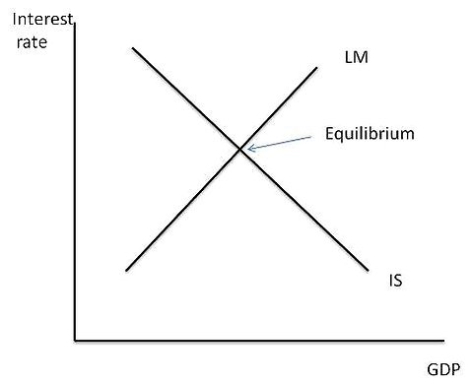

The point where the curves cross determines both GDP and the interest rate, and at that point both loanable funds and liquidity preference are valid.

What use is this framework? First of all, it helps you avoid fallacies like the notion that because savings must equal investment, government spending cannot lead to a rise in total spending – which right away puts us above the level of argument that famous Chicago professors somehow find convincing. And it also gets you past confusions like the notion that government deficits, by driving up interest rates, can actually cause the economy to contract.

Most spectacularly, IS-LM turns out to be very useful for thinking about extreme conditions like the present, in which private demand has fallen so far that the economy remains depressed even at a zero interest rate. In that case the picture looks like this:

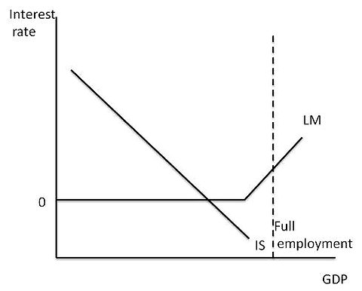

Why is the LM curve flat at zero? Because if the interest rate fell below zero, people would just hold cash instead of bonds. At the margin, then, money is just being held as a store of value, and changes in the money supply have no effect. This is, of course, the liquidity trap.

And IS-LM makes some predictions about what happens in the liquidity trap. Budget deficits shift IS to the right; in the liquidity trap that has no effect on the interest rate. Increases in the money supply do nothing at all.

That’s why in early 2009, when the WSJ, the Austrians, and the other usual suspects were screaming about soaring rates and runaway inflation, those who understood IS-LM were predicting that interest rates would stay low and that even a tripling of the monetary base would not be inflationary. Events since then have, as I see it, been a huge vindication for the IS-LM types – despite some headline inflation driven by commodity prices – and a huge failure for the soaring-rates-and-inflation crowd.

Yes, IS-LM simplifies things a lot, and can’t be taken as the final word. But it has done what good economic models are supposed to do: make sense of what we see, and make highly useful predictions about what would happen in unusual circumstances. Economists who understand IS-LM have done vastly better in tracking our current crisis than people who don’t.